Will AI Replace Human Writers in the Future?

In today’s times, Artificial Intelligence dominates the core of all industries. Hence, it is not unlikely to consider its impact even in the writing world. AI at all can replace human writers or not, is still a question of many. One thing can be assured that AI can always be working as human’s assistant in any given field.

# Can AI at all take up the human’s seat?

Artificial Intelligence governs our present world in multiple ways. Taking over the world of writing is not far away in near future. A study by **Mckinsey** claimsthe intelligent robots can replace upto **30%** of the world’s current workforce by **2030**. Around **400** million - **800** million jobs could be dislocated by then, making closely **375 million** people look for other kinds of jobs. Yet, it is to consider whether AI at all can replace writers.

# The role of AI in the world of writing.

More than one year back, British newspaper *The Guardian* had put a light on this topic with their article, titled *A robot wrote this entire article. Are you scared yet, human?* The report fundamentally talks about GPT-3, an AI writing tool.

Artificial intelligence (AI) is a wide-ranging branch of computer science concerned with building intelligent machines capable of performing tasks like human intelligence. The revolutionary AI application, **GPT-3**, makes the whole writing experience easier on any given topic. “Writer’s block” is a common phrase in the writing world; AI is gradually overpowering this.

# GPT-3 – the world’s largest neutral network machine learning model

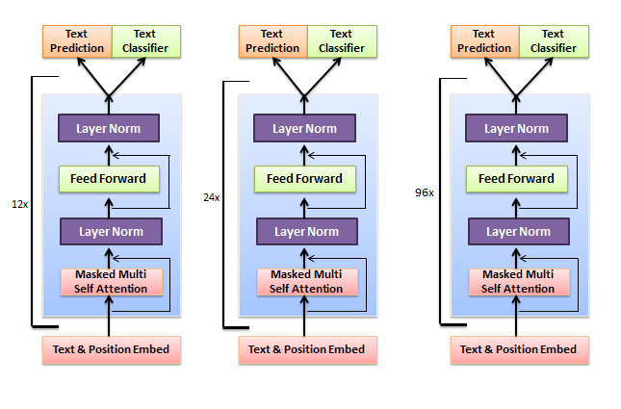Generative Pre-trained Transformer 3 is an autoregressive language model designed to produce human-like text. It is a third-generation language prediction model in the **GPT-n** series introduced by **OpenAI**. In May 2020, **OpenAI** introduced this model which has **175** billion parameters.

Companies like **Copysmith**, **Express** **Writers**, **OthersideAI** have built their platforms on GPT-3 to strengthen their content offerings.

* The distinctive feature of GTP-3 is that it has the capability to adapt any learning like humans. Furthermore, it can utilize training data to help it learn new information.
* It can easily perform several tasks like **fill in the blanks**, or **cloze test**, **answering questions** and **translation**.
* **It helps in researching, prepping, editing and publishing document in a minute.**

# AI doesn’t alone carry the writer’s fluency

In September 2020, **Microsoft** announced, it had given license to GPT-3’s technology for its ‘exclusive’ use to develop AI solutions to customers using **Azure OpenAI Service** . This makes it quite evident where this fast-growing industry is heading. Yet, in the same interview, the CEO of **Wordable** and **Codeless**, Brad Smith had put forward AI’s current limitations in content creation.

Smith outlines the biggest problem of the AI is that, its over-dependence on the patterns and probabilities of certain words and phrases appear next to each other when certain reference is mentioned.

“This means that currently, it can only take a mediocre pass at factual, information-based content. But even then it struggles to actually understand anything it’s saying. It is merely taking what’s already out there on certain topics and then playing a Robocop version of the word game Mad Libs,” he says.

AI cannot replenish writers entirely even if it is smart. The reason is this – when it comes to writing, there are still some things that AI can’t do. For example, it can’t create truly original content that can render emotions.

Technically, this GPT tool is developed with the combination of **AI** and **NLP** (Natural Language Processing) to streamline content marketing and management for companies across the board.

The problem with this AI tool is that while it can automate time-consuming publishing tasks, and predict the readers’ reading choice, it still cannot write well. Today, AI is still reliant on “**stringing-together**” concepts into some coherent ramble, but it cannot improvise the language to produce better narrative.

# What is the difference between AI and human writers?

Not only GPT-3, there are other AI writing assistants are available worldwide, **Grammarly**, **Writesonic**, **Jasper**, **Semrush**, to name a few. Writers can use these tools to make their content crisp; some may use them to rephrase. Yet, these tools cannot be completely relied on.

* AI cannot help in rendering emotions through the content the way humans would. It struggles to write coherent, engaging lengthy content in a flow or thought streams.
* Only humans can bring forth the variety of judgment and opinion into text. AI is yet to replicate such qualities.
* AI is a programming tool designed by another human being. So, technically, it can provide whatever it was programmed into, thus it lacks in creativity.

There’s one more study by **Ray Kurzweil** who made quite a number of predictions in 90s on **technological singularity**. In a 2005 TED Talk, he claimed, “Information technologies double their capacity, price performance, bandwidth, every year. And that’s a very profound explosion of exponential growth.”

In an interview at SXSW 2017, he stated, *“By 2029, computers will have human-level intelligence,”*

Given the speed at which technology is advancing, it isn’t doubtful that these predictions will also come true.

# Should writers be concerned with it?

There’s no doubt that content creation is a time-consuming process. Even with the help of AI tools, it takes a lot of time and effort to develop a professional piece of content. Hence, so many companies are turning to AI to get more content created in a shorter amount of time.

The truth is that businesses still need content writers. AI doesn’t always work properly in Search Engine Optimization (SEO). The future still is in the hold of content writers. AI isn't likely to completely replace content writers, but it can be useful in assisting them and speeding up the creation process.

**Reference**

<https://www.mckinsey.com/featured-insights/artificial-intelligence/global-ai-survey-ai-proves-its-worth-but-few-scale-impact>

<https://www.mckinsey.com/~/media/mckinsey/industries/advanced%20electronics/our%20insights/how%20artificial%20intelligence%20can%20deliver%20real%20value%20to%20companies/mgi-artificial-intelligence-discussion-paper.ashx>

